The title of the contribution (Title EN)
Florin Ghica – National Institute for Earth Physics, Măgurele, Romania, e-mail: (insert affiliate institution address)
(Author’s first name and last name, in this order, Institution, City, Country, email)
Mariana Popescu – University of Bucharest, Bucharest, Romania, e-mail: (insert affiliate institution address)
(Author’s first name and last name, in this order, Institution, City, Country, email)

Summary: A concise, factual abstract of no more than 150 words is required. The abstract should briefly state the purpose of the research, the principal results, and major conclusions. An abstract is often presented separately from the article, so it must be able to stand alone. For this reason, avoid any references, but if essential, then cite the author(s) and year(s). The abstract will be written in regular (size 11) TNR, 1.2 cm paragraph left-right.
Keywords: Provide 4-5 representative words for the paper, not included in the paper title. Use Times New Roman 11, italic, justified. (Keywords)
1. Introduction (Chapter)
The title “Introduction” will be numbered, written in small capitals (size 12), bolded, and aligned left.
In the introduction, the state of the art of the domain will be mentioned (by citing the corresponding references), and the objectives of the paper will be stated.
The contribution will consist of 3 to a maximum of 4 pages (an even number is preferable, size A4, all margins at 2.5 cm, gutter at 0.5 cm and positioned to the left), the font used being TNR, size 12, the paragraphs being separated from one another with one line of size 6. (Normal text). Save your file both in PDF format and in docx format (Word 2007 or higher) or doc format (older Word versions).
2. Paper content (the title of the first chapter) (Chapter)
Chapter titles will be numbered, written in small capitals (size 12), bolded, and left-aligned.
The International System of Units will be used. Papers are to be submitted in English.
2.1. Subchapter Subchapter (1.1)
2.1.1. Subsubchapter Subsubchapter (1.2.1)
3. Paper content (the title of the second chapter) (Chapter)
Equations. Equations are to be numbered consecutively, numbers to be indented to the right, and typeset with the equations editor: Settings – size: 12, 10, 7, 18, 12, style: italic variables, LG Greek italic.
(Equations) (1)

Tables. Tables are to be typeset in TNR size 11. The number and the title of the table are to be centred, and its numeration written in italics (size 11). The table is centred. Use the table function, not spreadsheets, to make tables.

Table 1. (Number of the Table) Melting points and basic analysis (Table Title)

Compounds | Mp(⁰C) | Chemical formula | N (%)
Compounds | Mp(⁰C) | Chemical formula | Calculated | Resulted
3A | 178 | C₂₉H₃₄N₂O | 6,57 | 3A
3B | 264 | C₂₉H₃₃N₃O₃ | 8,92 | 3B
3C | 232 | C₂₉H₃₂N₄O₅ | 10,85 | 3C
5A | 185 | C₂₉H₃₄N₂O | 6,56 | 5A
5B | 242 | C₂₉H₃₃N₃O₃ | 8,92 | 5B

Figures. Figures are to be placed centred. Centre the legend under the figure, in TNR size 11.
Photographs, drawings, or paintings should have a minimum resolution of 300 dpi (600 dpi for colour figures). Please make sure that artwork files are in an acceptable format (TIFF (or JPEG), EPS (or PDF), or MS Office files) and with the correct resolution. Do not include titles or captions within your illustrations. Fonts in the figures must be embedded.
Under no circumstances is it acceptable to change the orientation of any page to “Landscape” to accommodate an illustration or exhibit – these pages will not output properly in the proceedings volume.
All figures and tables must be referred to and described in the text.

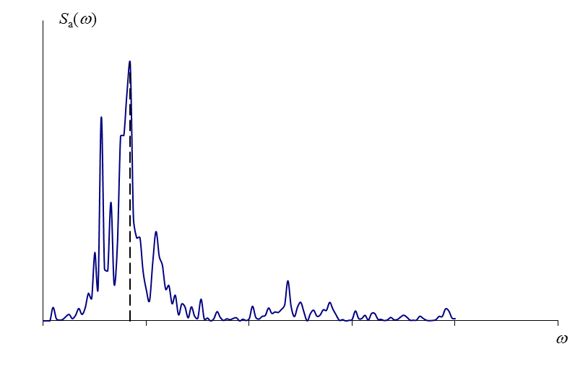
Fig. 1 - The legend is centred (size 10) (Figure)
4. Conclusions (Chapter)
The contribution will conclude with the main results and conclusions obtained by the author(s).
Acknowledgements (Chapter)
If necessary.
References (Chapter)
The references must be cited in the text using the author-year format, with the author name and publication year in parentheses. For example: Kronrod et al. (2013); Pavel et al. (2020).
The list of references (in APA format) should include only works cited in the text that have been published. References should be arranged alphabetically according to the last name of the first author of each publication.

Journal Article:
Author, A. A., & Author, B. B. (Year). Title of the article in sentence case. Title of Periodical, Volume(Issue), page range. doi.org

Book:
Author, A. A. (Year of publication). Title of work: Capitalize the first word of the subtitle. Publisher.

